**Easy healthy lunch ideas for weight loss**  
  
We all know that staying healthy is one of the essential factors in any human being's life. Staying fit is one of the reasons to stay away from all kinds of diseases, many other problems which can cause middle-aged such as cholesterol, diabetes, blood pressure problems, and whatnot. Weight loss is not easy, but a determination can completely change anybody's transformation. Weight loss is essential not only for yourself, but to stay fit can give you many more benefits than staying in obesity. If you are thinking of a low-calorie diet and having a healthy lifestyle and then Below mentioned **healthy lunch ideas for weight loss** could help you to get your ideal weight and of course, a significant transformation.  
Well, it is not accessible to diet when there is so much junk food around you, but if you are thinking of staying healthy, then you can quickly get these **healthy lunch ideas for weight loss** which can not only provide you vitamins and nutrients, but it will also keep you fit.  
  
**1. White bean creamy avocado wrap**

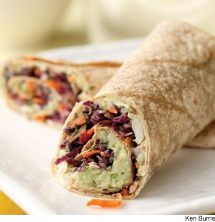
We all know that grabs are one of the best things one can have dinner weight loss as it makes your stomach full, and one cannot ask for anything more. When it comes to suggesting **healthy lunch ideas for weight loss**, this is the best wrap one can have. By adding white beans mashed and some ripe avocado will give you the best taste. You can also add your favorite vegetable, and if you're a cheese lover, then adding cheddar with some spicy sauce can make your wrap even better. If you are a working human, then this is easy to make recipes and packing it in a lunch box, and eating it in your break can make your weight loss much useful, and this is the best portable lunch idea.  
Credits: <http://www.eatingwell.com/recipes/18567/lifestyle-diets/vegetarian/weight-loss/?page=4>  
**2. Soups and grilled sandwiches**  
  
Who doesn't love having cheese grilled sandwiches in their weight loss? One can have various versions of cheese grilled sandwich either with fruit sliced in it or some vegetables which can give perfect healthy lunch. Also, one can use butternut squash for soups or any vegetable soup with can enhance flavors for your grilled sandwich too! One cannot miss having this for lunch, isn't it? When it comes to having cheese grilled sandwiches, who won't love it?  
Credits:<http://www.eatingwell.com/recipes/18567/lifestyle-diets/vegetarian/weight-loss/?page=4>  
**3. Love for Smoothies!**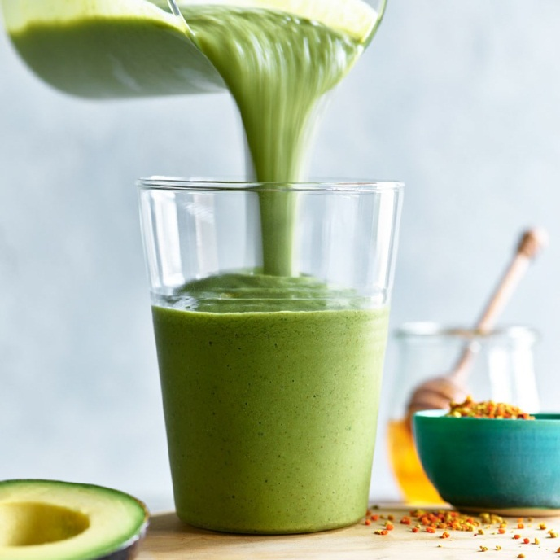  
When it comes to smoothies, we all know that having them in the morning or with a meal can make us feel much better. This is one of the best **healthy lunch ideas for weight loss**. Having a green smoothie can make your internal system much stronger. The combination of avocado with Chia seeds and making it a creamy smoothie is worth drinking. Smoothie is our best to have in a weight loss procedure where one can efficiently work and sip smoothies, which is not only healthy but has fibers too.  
Credits: <http://www.eatingwell.com/recipes/18567/lifestyle-diets/vegetarian/weight-loss/?page=2>  
  
**4. Oatmeal and eggs with cheddar**

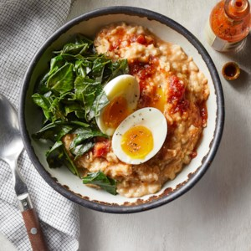

We all love oatmeal, and it is the perfect dish for weight loss. One can easily make oatmeal eggs with cheddar cheese. One can have a typical savory taste of oatmeal and add their favorite spices too. It will be a perfect lunch for the people who love oatmeal and gain the ideal amount of protein and nutrients. You can also have this with any sauces too.

Credits: <http://www.eatingwell.com/recipes/18567/lifestyle-diets/vegetarian/weight-loss/?page=2>  
 **5. All-Set Prepared Packs**  
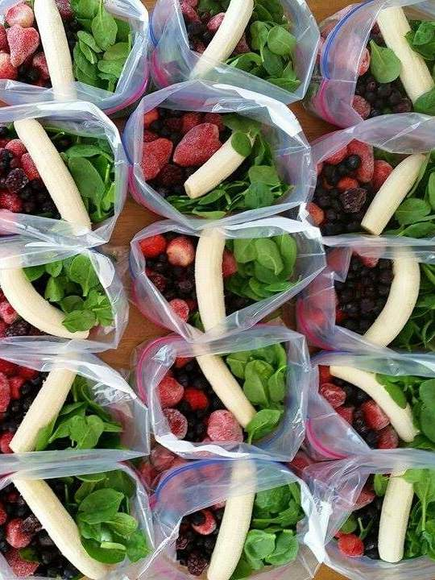  
If you need **healthy lunch ideas for weight loss**, you can easily prepare this fact. All you need to do is get your favorite fruits, and you can either eat it in the morning or at lunchtime. In case if you are having a breakfast which has a high protein and nutrients, then you can quickly eat these prepared packs which you can get in the market also. This will not only give you energy for a workout, but it will also help you to chew the food, which is useful for reducing the double chin. Also, you can quickly grind it and drink it as a smoothie. This is the easiest recipe, and if you are a working person, then this can be your perfect lunch. In case you don't want to feel lazy just by sitting in one place, then these facts can help you to feel fresh and light.  
Credits: <https://www.health.com/food/pinterest-meal-prep-recipes-weight-loss>  
**6. Rice Burrito and Black Bean Salad**  
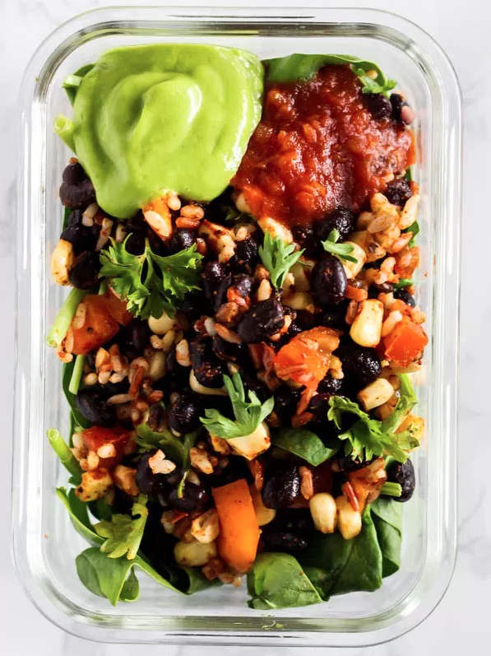  
We all know that the taste of burritos can make us feel much energetic. This is one of the **healthy lunch ideas for weight loss**, where one can easily prepare a black beans burrito salad. One can add their favorite vegetables, such as corn, tomatoes. It is easy to make, and one can feel light after consuming it. You can also add avocado, salsa sauce, and spices to make it more tasty and delicious.  
Credits: <https://www.health.com/food/pinterest-meal-prep-recipes-weight-loss>  
**7. Shrimp Avocado Salad**  
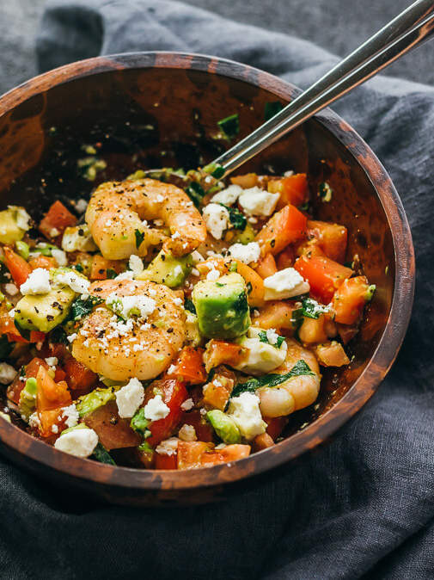
As weight loss is not completed without adding salads in your meals, if you are thinking of a mixture that can be easily made, shrimp and avocado salad are one of the best salad which can go either for your lunch are you can have it for dinner. In case if you want to make it more colorful, you can add any favorite vegetables or spices to make it tangy and tasty. Who can even say 'no' to avocados?  
Credits: <https://www.health.com/food/pinterest-meal-prep-recipes-weight-loss>  
**8. Avocado-Tuna Sandwich**  
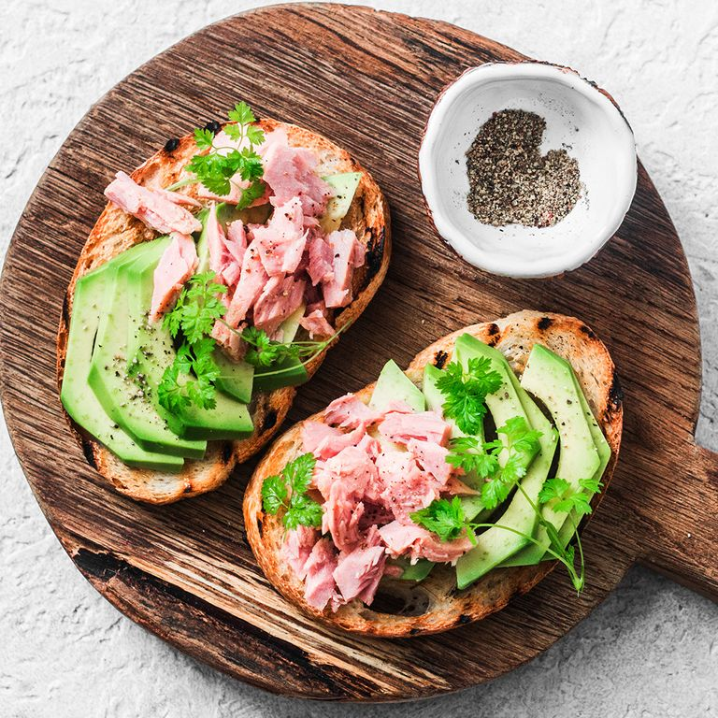  
Who doesn’t like an open sandwich? When it comes to **healthy lunch ideas for weight loss** and avocado-tuna sandwich is one of the best and tastiest sandwiches, one can ever have it. All you have to do is get your favorite vegetables and prepare lunch in whole grain bread. You can add lemon juice and make sure that you have drained the tuna before adding in the sandwich. It can also add black pepper in the sandwich for adding some spiciness.  
Credits: <https://www.womenshealthmag.com/weight-loss/a19990069/lunches-for-weight-loss/>  
**9. A Tofu Salad**  
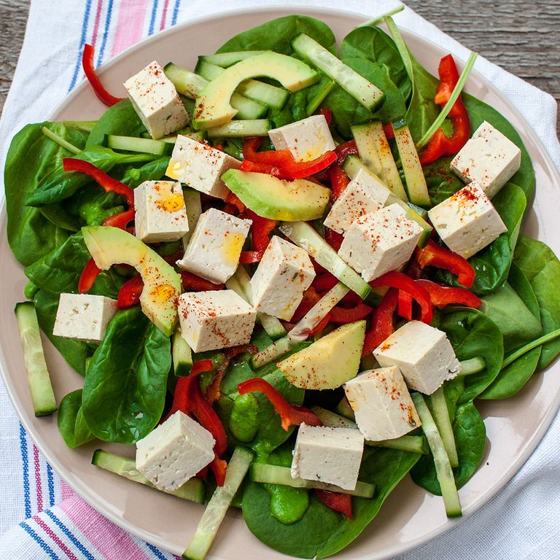
If you are thinking of keeping your lunch a bit light, I tofu salad is one of the most natural recipes you can make it which has the right amount of protein and carbohydrate. All you have to do is chop some vegetables such as capsicum, spinach, avocado. You can add spices and lemon juice to make it taste much better. I tofu salad is very lightweight, and it is one of the best **healthy lunch ideas for weight loss**. And when it comes to thinking of weight loss, avocados work best.  
Credits: <https://www.womenshealthmag.com/weight-loss/a19990069/lunches-for-weight-loss/>  
**10. Spicy Chicken Salad**  
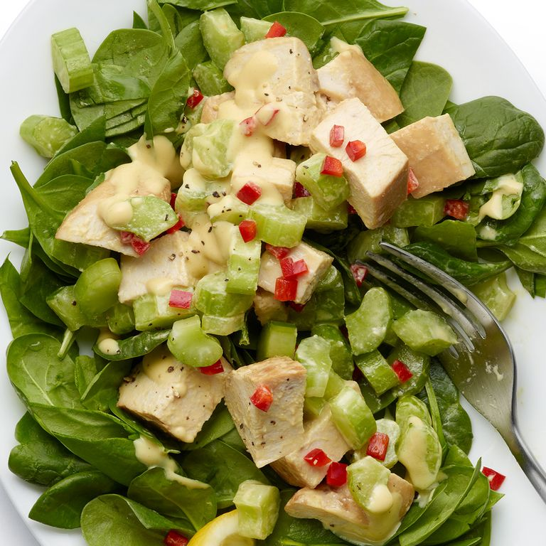
Every person loves spicy food. When it comes to lunch, we all want some tasty food and help you with a weight loss. Spicy chicken salad is one of the most recommended mixtures. It can be made quickly, and you don't have to buy ingredients from the grocery shop. All you have to do is add capsicum, chicken, jalapeños, black pepper, and spinach. You can also add mustard and lemon juice. Mix it well, and your spicy chicken salad is ready. It is quite easy to make, and it just has 6 to 7 ingredients.  
Credits: <https://www.womenshealthmag.com/weight-loss/a19990069/lunches-for-weight-loss/>  
**11. Egg Salad Sandwich**  
  
Weight loss 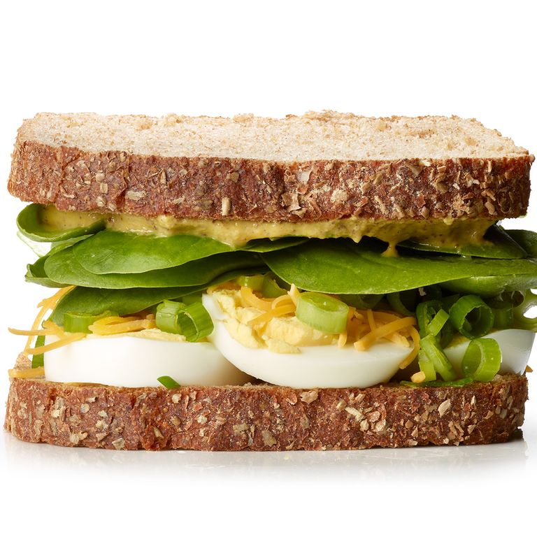is important. And gaining vitamins and proteins are quite remarkable. An excellent sandwich is one of the easiest sandwich ones that can make a home. They can eat it at breakfast, lunch for a healthy protein mail. One should make a sandwich in multigrain bread. You can add spinach, lemon juice, cheddar cheese, and mustard. Healthy lunch ideas for weight loss have to cover an egg salad sandwich. Sandwiches cannot only make your stomach full, but they can give you the right amount of nutrients.  
Credits: <https://www.womenshealthmag.com/weight-loss/a19990069/lunches-for-weight-loss/> **12. Mozzarella and Tomato Salad  
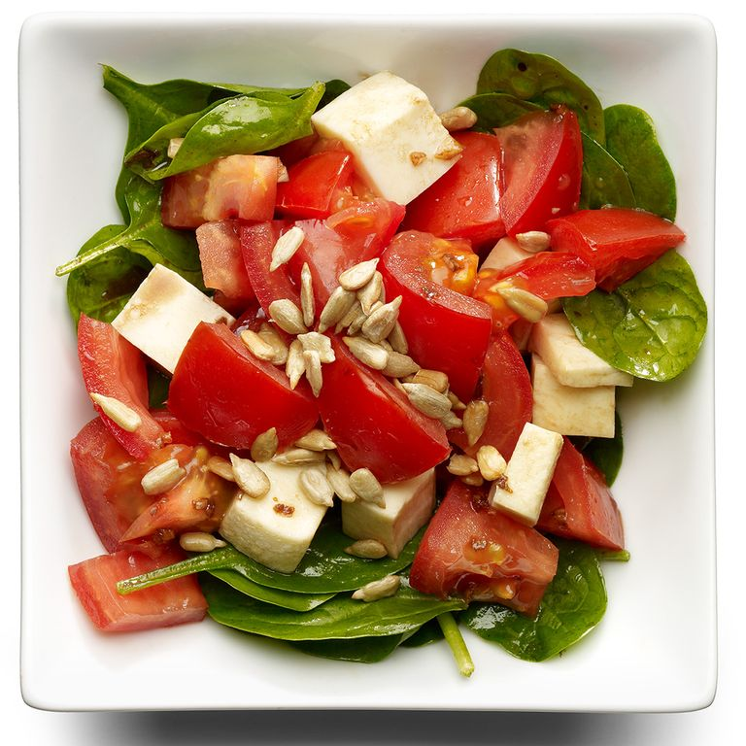**We all want cheese in our diet. Weight loss is not completed without having cheese in your salad or sandwiches. One of the best mixtures is mozzarella and tomato salad. It is one of the tastiest salad. No one can Be disappointed if cheese is added in their weight loss diet. You can add fresh spinach leaves, garlic, olive oil, and vinegar. To add some spiciness, you can add black pepper. Mix it well and have it clean.  
Credits: <https://www.womenshealthmag.com/weight-loss/a19990069/lunches-for-weight-loss/>  
**13. Cucumber and Turkey Sandwiches**  
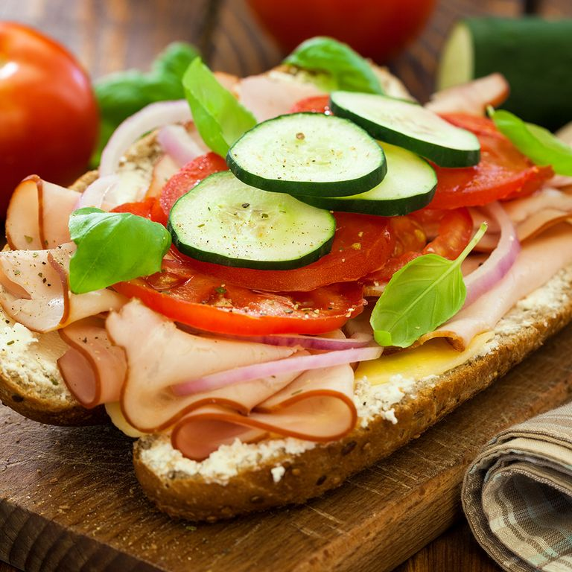  
Calorie counts are quite important when it comes to weight loss. If you are looking for **healthy lunch ideas for weight loss**, then make sure that your all meals contain a moderate amount of calories. Cumber and turkey sandwich is best for calorie count. You can make the sandwich in multigrain bread by adding seedless cucumber, turkey, and some spices. It will make your lunch break much better.  
Credits: <https://www.womenshealthmag.com/weight-loss/a19990069/lunches-for-weight-loss/>

Above mentioned **healthy lunch ideas for weight loss** will give you the best lunch breaks ever. From healthy salads to sandwiches, you can improve your health by gaining the right amount of proteins and vitamins. Make sure that you work out equally because burning calories is also necessary as much as increasing calories.

One should eat healthy when it comes to weight loss instead of starving the whole day. All your calorie counts should be managed, and your meals should be completely healthy. Make sure that you work out equally because burning calories is also necessary as much as gaining calories. One should eat healthy when it comes to weight loss instead of starving the whole day. All your calorie counts should be managed, and your meals should be completely healthy.